📘 Assignment: Threat Landscape

🔹 Task 1: Examples of Cyber Threats
Threat Type | Real-World Example | How the Attack Works
Phishing | Fake WhatsApp verification message | Attackers send messages asking users to click a fake login link to steal account credentials.
Phishing | Fake Paytm KYC update | Victims receive emails or SMS claiming KYC has expired and are redirected to a fake login page.
Phishing | Fake Flipkart order confirmation | Users receive fake order emails asking them to log in or cancel an order using a malicious link.
Ransomware | WannaCry | Encrypts files on infected systems and demands payment for the decryption key.
Ransomware | LockBit | Encrypts company data and threatens to publish it unless a ransom is paid.
Ransomware | Ryuk | Targets organizations by encrypting servers and disrupting operations.
Insider Threat | Employee misuses customer database | An employee intentionally copies customer information for unauthorized use.
Insider Threat | Unauthorized access by staff | An employee views confidential records without business approval.
Insider Threat | Accidental data leak | An employee mistakenly shares confidential information with the wrong recipient.

🔹 Task 2: Simulated Phishing Exercise (Controlled Environment)
Objective: Learn how phishing attacks work in a safe, isolated laboratory environment.
Answer:

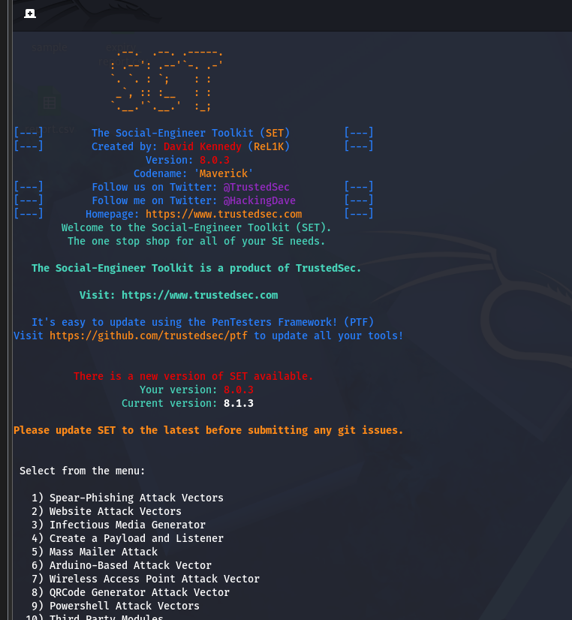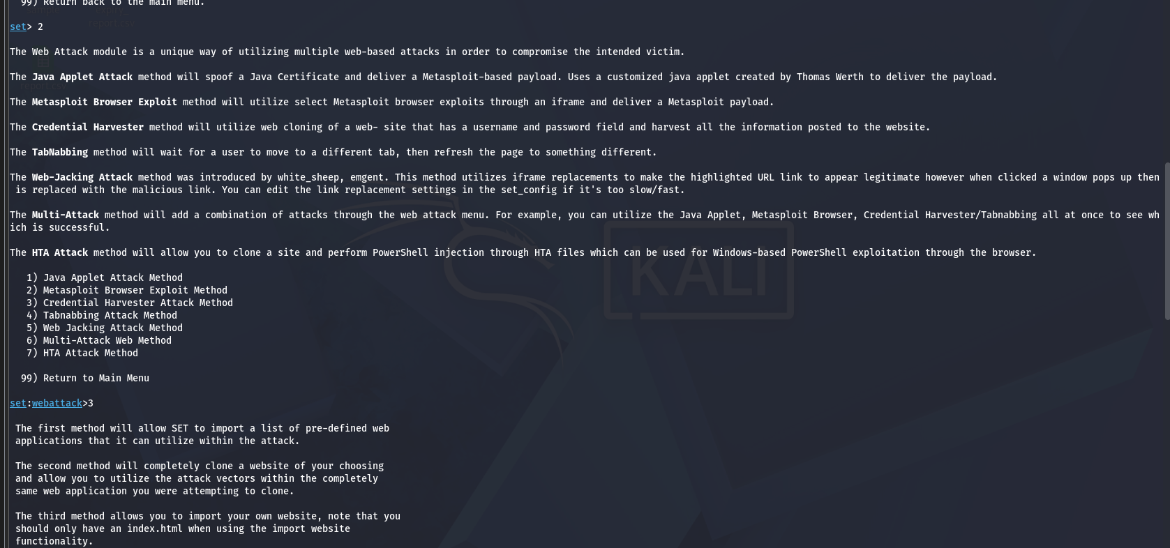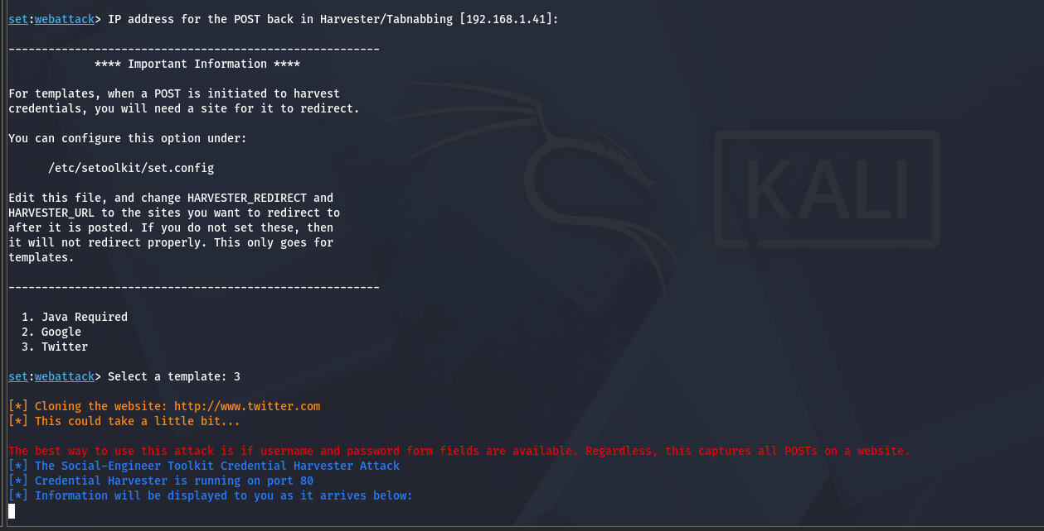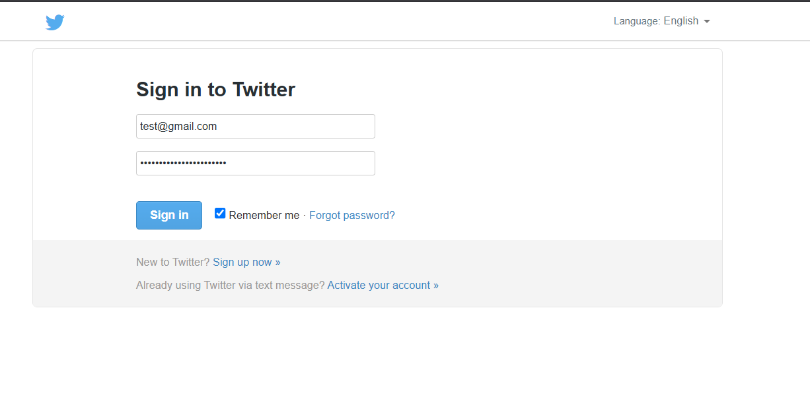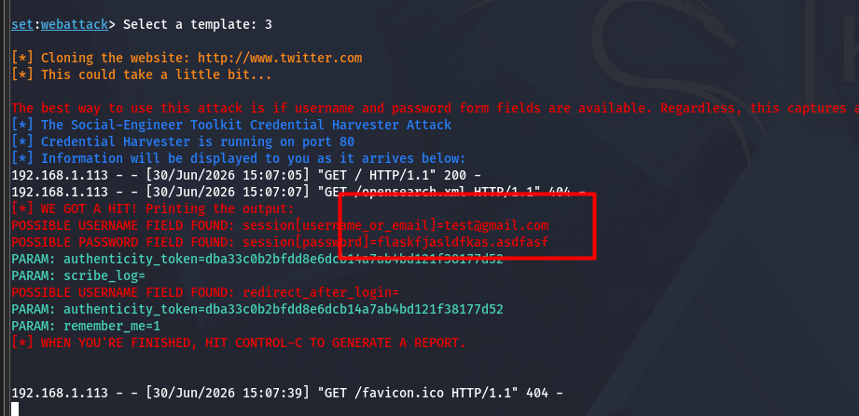
A phishing simulation was conducted in a controlled cybersecurity lab using an awareness-training platform. The exercise demonstrated how a fake login page can be used to educate users about phishing risks without targeting real people or collecting real credentials.
Observation:
- The simulation showed how users might be tricked by a convincing-looking login page.
- No real usernames, passwords, or personal information were used.
- The activity was performed only for educational purposes in a local lab environment.
Learning Outcome:
- Users should always verify website URLs.
- Enable Multi-Factor Authentication (MFA).
- Never enter credentials on suspicious websites.
Note: Ethical phishing simulations should only be performed in authorized training environments with permission.

🔹 Task 3: Email Spoofing Demonstration
Objective: Understand how sender information can be misleading and how organizations defend against spoofing.
Answer:
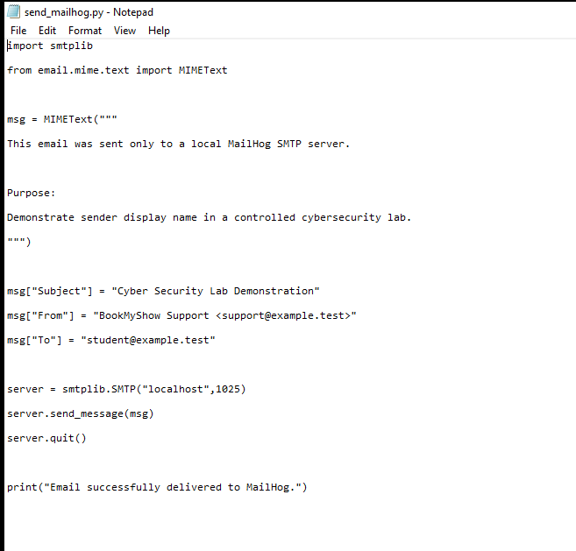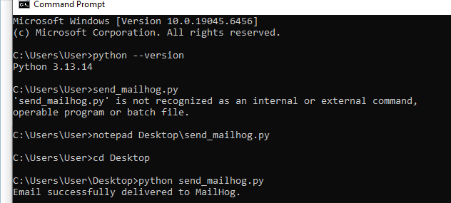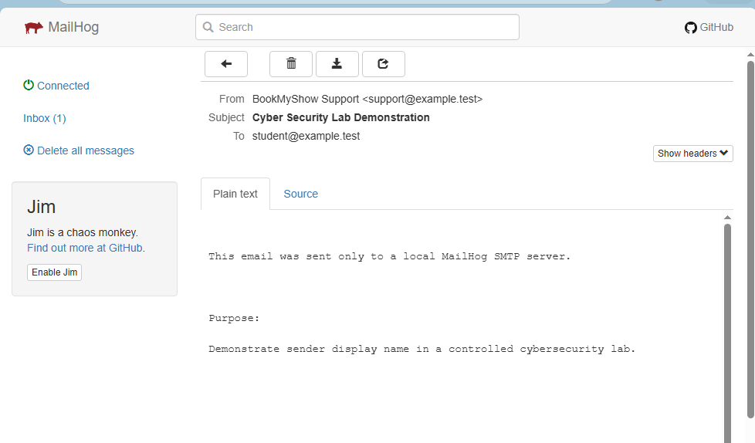
A controlled demonstration showed that an email's display name can appear to come from a trusted organization even though the underlying sender information is different.
Observation:
- The display name alone should not be trusted.
- The actual sender address and email authentication determine legitimacy.
How to Detect Email Spoofing
- Verify the sender's email address.
- Check email headers if something looks suspicious.
- Be cautious of urgent requests or unexpected attachments.
- Avoid clicking links without verifying the destination.
Note: The demonstration should only be performed in an authorized test environment using test accounts.

🔹 Task 4: Phishing Prevention Techniques
Technique 1: Enable Two-Factor Authentication (2FA)
Implementation:
- Enabled 2FA on the email account.
- Login now requires both a password and a verification code.
Benefit:
Even if a password is stolen, attackers cannot access the account without the second authentication factor.

Technique 2: Verify Email Headers and Sender Information
Implementation:
- Checked the sender's email address before opening links or attachments.
- Verified that messages came from official domains.
Benefit:
Helps identify spoofed or fake emails before interacting with them.

🔹 Task 5: How a Phishing Attack Could Target a Food Delivery User
Example Scenario
A user receives an email claiming to be from Zomato or Swiggy stating:
"Your account has been suspended. Verify your account immediately to continue ordering food."
The email includes a fake website that looks similar to the official login page. If the user enters their credentials, the attacker may steal them.

How to Recognize and Avoid Phishing Attacks
Step 1: Check the Sender
- Verify the sender's email address carefully.
- Official companies use their legitimate domains.
Step 2: Inspect Links
- Hover over links before clicking.
- Ensure they lead to the company's official website.
Step 3: Look for Urgent Language
- Be cautious of messages demanding immediate action or threatening account suspension.
Step 4: Never Share Sensitive Information
- Legitimate companies do not ask for passwords or one-time passwords (OTPs) through email.
Step 5: Enable Multi-Factor Authentication
- Add an extra layer of protection to your account.

Warning Signs of Fake Emails or Websites
- Misspelled or unusual website addresses.
- Urgent messages requesting immediate action.
- Requests for passwords, OTPs, or payment information.
- Poor grammar or spelling mistakes.
- Unexpected attachments or suspicious links.

✅ Conclusion
Cyber threats such as phishing, ransomware, and insider attacks continue to target individuals and organizations. Understanding how these attacks operate—and, more importantly, how to recognize and prevent them—is a fundamental cybersecurity skill. Combining user awareness with controls such as MFA, careful verification of email sources, and secure browsing practices significantly reduces the risk of compromise.

